

DATA ANALYSIS AND VISUALIZATION

PROJECT REPORT
(Project Semester January–April 2025)

India District-Wise Road Accident Analysis and Visualization

Submitted by

Name: SADU RAMCHARAN
Registration No.: 12502844
Programme and Section : B.TECH -CSE – 2M032
Course Code : INT387

Under the Guidance of

(JAFFAR AMIN CHACKET with UID: 30453 and ASSISTANT PROFESSOR)

Discipline of CSE/IT
Lovely School of Computer Science and Engineering
Lovely Professional University, Phagwara

2025

DECLARATION

I,SADU RAMCHARAN student of DATA SCIENCE (Programme Name) under CSE/IT Discipline at Lovely Professional University, Punjab, hereby declare that all the information furnished in this project report is based on my own intensive work and is genuine.

This report is submitted in partial fulfilment of the requirements for the course of Data Analysis and Visualization. The work presented here has not been submitted elsewhere for the award of any other degree or diploma.

Date: 23-04-2026 Signature: SADU RAMCHARAN

Registration No.: 12502844 Name of Student: SADU RAMCHARAN

CERTIFICATE

This is to certify that SADU RAMCHARAN (student's name) bearing Registration No. 12502844 has completed the Data Analysis and Visualization project titled, "India District-Wise Road Accident Analysis and Visualization (2003–2015) using Microsoft Power BI" under my guidance and supervision. To the best of my knowledge, the present work is the result of his/her original development, effort and study.

Signature and Name of the Supervisor
Designation of the Supervisor
School of COMPUTER SCIENCE AND ENGINEERING
Lovely Professional University
Phagwara, Punjab.

Date: 23-04-2026

ACKNOWLEDGEMENT

I would like to express my sincere gratitude to my faculty coordinator for their constant guidance, encouragement and invaluable support throughout the course of this project. Their insights into the field of Data Analysis and Visualization helped me understand not just the tools but also the real-world significance of data-driven decision making.

I am grateful to the Lovely Professional University for providing the necessary academic environment and resources to carry out this project. The structured curriculum of the Data Analysis and Visualization course gave me the foundation required to work with a real-world dataset and build a meaningful dashboard.

I also acknowledge the Government of India and the Ministry of Road Transport and Highways for making the district-wise road accident dataset publicly available. This dataset forms the backbone of this project and the visualizations built upon it.

Finally, I thank my peers and friends for their continuous motivation and constructive feedback during the development of this dashboard.

Name: SADU RAMCHARAN

Registration No.12502844

TABLE OF CONTENTS

DECLARATION 1
CERTIFICATE 1
ACKNOWLEDGEMENT 1
TABLE OF CONTENTS 1
1. Introduction 1
1.1 Objectives 1
2. Source of Dataset 1
2.1 Dataset Details 1
3. Dataset Preprocessing 1
3.1 Steps Performed in Power Query Editor 1
4. Analysis on Dataset 1
4.1 National Trend Analysis 1
4.2 State-Wise Accident Distribution 1
4.3 District-Wise Hotspot Identification 1
4.4 Geographic Distribution — Filled Map 1
4.5 KPI Cards — Key Metrics at a Glance 1
4.6 State Deep Dive — Interactive Page 2 1
5. Conclusion 1
6. Future Scope 1
7. References 1

1. Introduction
Road accidents remain one of the most serious public health and safety concerns in India. Every year, thousands of lives are lost and many more are injured due to road accidents across the country. Understanding the patterns, trends and distribution of road accidents at the district and state level is critical for policymakers, urban planners and law enforcement agencies to take targeted and effective action.

This project focuses on the visual analysis of a district-wise road accident dataset covering all major states and union territories of India from the year 2003 to 2015. The dataset contains accident counts at the district level for each year, providing a rich source for temporal and geographical analysis.

The primary tool used for this project is Microsoft Power BI, which is an industry-standard business intelligence and data visualization platform. Power BI allows users to connect to datasets, build interactive dashboards and share insights in a visually compelling manner. This project demonstrates how raw accident data can be transformed into meaningful dashboards that can be used to derive insights and support decision-making.

1.1 Objectives
- Analyse the trend of road accidents in India from 2003 to 2015 at the national level.
- Identify the top states and districts with the highest number of road accidents.
- Determine the peak year of road accidents across the entire dataset.
- Visualize state-wise and district-wise accident distribution using interactive Power BI visuals.
- Build an interactive multi-page Power BI dashboard with slicers and cross-filtering for deeper exploration.
- Present the findings in a clear and professional manner suitable for academic submission and presentation.

2. Source of Dataset
The dataset used in this project is the India District-Wise Road Accident Data for the years 2003 to 2015. This dataset was originally compiled from the records maintained by the Ministry of Road Transport and Highways (MoRTH), Government of India, and is publicly available for research and educational purposes.

2.1 Dataset Details
Field | Description
Dataset Name | District-wise Road Accidents India 2003–2015
Source | Ministry of Road Transport and Highways (MoRTH), Government of India
File Format | CSV / Excel (.xlsx) — unpivoted format with Year and Accidents columns
Time Period | 2003 to 2015 (13 years)
Total Records | 5,324 rows (after unpivoting)
States/UTs | 37 States and Union Territories
Districts | 428 Districts
Columns | State, District, Year, Accidents

The original dataset was in wide format with separate columns for each year (2003, 2004 … 2015). Before loading into Power BI, the data was unpivoted to convert it into a long format with a single Year column and a single Accidents column. This transformation was necessary for all Power BI visuals and DAX measures to function correctly.

3. Dataset Preprocessing
Before building the Power BI dashboard, the raw dataset required several preprocessing steps to ensure data quality and compatibility with Power BI's data model. All preprocessing was performed using Power BI's built-in Power Query Editor.

3.1 Steps Performed in Power Query Editor
Step 1 — Loading the data
The dataset was loaded into Power BI Desktop using Home → Get Data → Excel Workbook. The file was selected and the correct table/sheet was chosen from the Navigator pane.

Step 2 — Unpivoting the year columns
The original dataset had year values as column headers (2003, 2004, … 2015). This wide format is not suitable for time-series analysis in Power BI. The year columns were selected, then Transform → Unpivot Columns was applied. This converted the data into a long format with two new columns named Attribute (renamed to Year) and Value (renamed to Accidents).

Step 3 — Renaming columns
The columns were renamed to clean, descriptive names: State, District, Year, Accidents. This was done by double-clicking each column header in Power Query.

Step 4 — Changing data types
The Year column was changed from Text to Whole Number. The Accidents column was confirmed as Whole Number. The State and District columns were kept as Text type.

Step 5 — Handling missing values
The dataset was checked for null or blank values using Transform → Replace Values and the column profiling tools in Power Query. No significant missing values were found in the core columns. A few districts had zero accident counts for specific years, which were retained as valid zero values.

Step 6 — Setting geographic data category
In Power BI's Data View, the State column's Data Category was set to State or Province and the District column was set to County under Column Tools. This enabled the Filled Map visual to correctly identify and plot geographic locations on the map.

Step 7 — Closing and applying changes
After all transformations were complete, Home → Close & Apply was clicked to load the cleaned data into the Power BI data model.

4. Analysis on Dataset
The analysis is divided into multiple objectives. Each objective focuses on a specific aspect of the road accident data and is supported by dedicated Power BI visuals and DAX measures.

4.1 National Trend Analysis
General Description
This objective analyses the total number of road accidents in India from 2003 to 2015 at the national level to identify whether accidents have been increasing, decreasing or fluctuating over the years.

Specific Requirements
- A Year column (numeric) and an Accidents column (numeric) are required.
- A DAX measure for Total Accidents: Total Accidents = SUM(Table[Accidents])
- A line chart visual in Power BI with Year on the X-axis and Total Accidents on the Y-axis.

Analysis Results
The total road accidents at the national level showed a steady increase from 2003 to 2010, reaching a peak in 2010 with approximately 527,512 accidents. After 2010, the numbers showed a gradual decline, reaching approximately 500,279 in 2015. This suggests that road safety measures implemented after 2010 may have had some positive effect.

Visualization
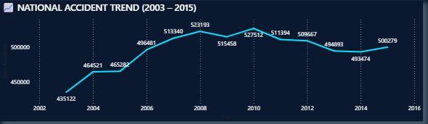
[ INSERT SCREENSHOT HERE ] Line Chart — National Accident Trend 2003–2015

4.2 State-Wise Accident Distribution
General Description
This objective identifies which states in India have the highest cumulative road accidents over the 13-year period from 2003 to 2015.

Specific Requirements
- State column (text) and Total Accidents measure are required.
- A horizontal bar chart or clustered bar chart visual in Power BI.
- A Top N filter applied to show only the top 10 states by total accidents.

Analysis Results
Tamil Nadu consistently recorded the highest number of road accidents over the 13-year period with a total of 911,917 accidents, followed by Karnataka (748,233) and Andhra Pradesh (644,019). These three states together account for a significant share of total national accidents. Southern and central states dominate the top positions, indicating a need for stronger road safety interventions in these regions.

Visualization
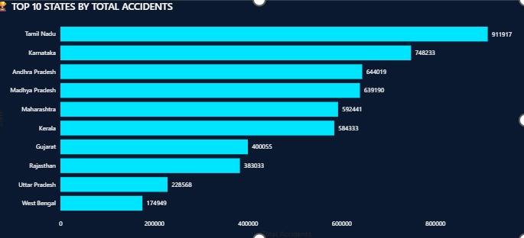
[ INSERT SCREENSHOT HERE ] Bar Chart — Top 10 States by Total Accidents

4.3 District-Wise Hotspot Identification
General Description
This objective identifies the districts with the highest concentration of road accidents to pinpoint geographic hotspots at a more granular level than state-wise analysis.

Specific Requirements
- District column (text) and Total Accidents measure are required.
- A Treemap visual or clustered column chart in Power BI.
- Top N filter set to Top 15 districts by Total Accidents.

Analysis Results
The treemap reveals that a handful of districts contribute disproportionately to the national accident count. Districts within Tamil Nadu and Karnataka dominate the top positions. This analysis is particularly useful for law enforcement agencies and local governments to prioritise resources and infrastructure improvements in the most accident-prone areas.

Visualization
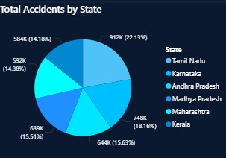

[ INSERT SCREENSHOT HERE ] Treemap — Top 15 Districts by Total Accidents

4.4 Geographic Distribution — Filled Map
General Description
This objective visualises the state-wise distribution of road accidents on a geographic map of India to provide a spatial understanding of accident concentration.

Specific Requirements
- State column with Data Category set to State or Province.
- Total Accidents measure for colour saturation.
- Filled Map visual in Power BI.

Analysis Results
The filled map clearly shows that southern and western states carry the darkest shading, indicating the highest accident densities. States in the north-eastern region and smaller union territories appear lighter, reflecting lower accident counts. This geographic view makes it immediately clear to any audience which regions need the most attention without needing to read numbers.

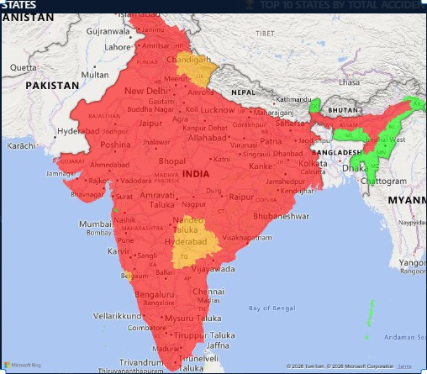
Visualization

[ INSERT SCREENSHOT HERE ] Filled Map — State-Wise Accident Distribution across India

4.5 KPI Cards — Key Metrics at a Glance
General Description
This objective presents the most important summary statistics of the dataset in a concise KPI card format at the top of the dashboard for quick reference during presentations.

Specific Requirements
Five DAX measures were created and assigned to five KPI card visuals:

Field | Description
Total Accidents | SUM(Table[Accidents]) — Total across all states, districts and years
Avg Per Year | DIVIDE([Total Accidents], 13) — Average annual national accidents
Peak Year | MAXX(TOPN(1, SUMMARIZE(..., Year, Total), [Total], DESC), [Year]) = 2010
Top State | MAXX(TOPN(1, SUMMARIZE(..., State, Total), [Total], DESC), [State]) = Tamil Nadu
Total Districts | DISTINCTCOUNT(Table[District]) = 428

Analysis Results
The five KPI cards provide an immediate summary: India recorded over 6.5 million road accidents between 2003 and 2015, averaging approximately 500,279 per year. The peak year was 2010 with 527,512 accidents. Tamil Nadu was the top contributing state and the dataset covers 428 districts across 37 states and union territories.

Visualization

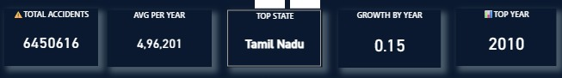
[ INSERT SCREENSHOT HERE ] KPI Cards — Total Accidents, Avg Per Year, Peak Year, Top State, Total Districts

4.6 State Deep Dive — Interactive Page 2
General Description
This objective provides a dedicated second page in the dashboard where the user can select any state and any year range using slicers, and all visuals on the page automatically update to show only that state's data.

Specific Requirements
- A State slicer (dropdown style) and a Year slicer (between/range style).
- A line chart showing year-wise accident trend for the selected state.
- A bar chart showing top 10 districts within the selected state.
- A card visual showing total accidents for the selected state.

Analysis Results
When Tamil Nadu is selected in the State slicer, the line chart shows a consistent upward trend in accidents from 2003 to 2015. The district bar chart reveals that specific districts within Tamil Nadu account for the majority of that state's accidents. The card visual updates to show Tamil Nadu's total of 911,917 accidents. This interactive page is especially useful during the viva or presentation, as the audience can explore any state they are interested in.

Visualization
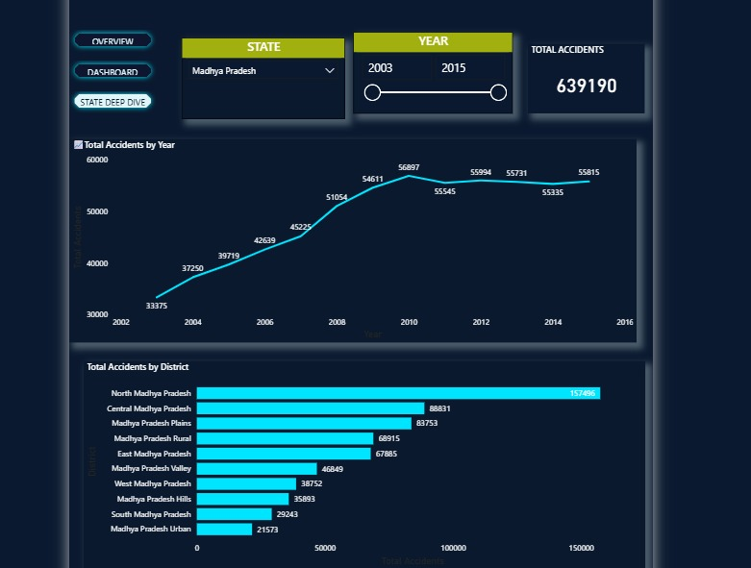
[ INSERT SCREENSHOT HERE ] Page 2 — State Deep Dive with Slicers, Line Chart and District Bar Chart

5. Conclusion
This project successfully demonstrates the use of Microsoft Power BI as a tool for data analysis and visualization of a real-world road accident dataset. The district-wise road accident data of India from 2003 to 2015 was cleaned, preprocessed and loaded into Power BI to build an interactive multi-page dashboard.

The key findings from this analysis are as follows. Road accidents in India peaked in the year 2010 with over 527,000 incidents at the national level, after which there was a gradual decline suggesting the positive impact of road safety campaigns and policy measures. Tamil Nadu was identified as the state with the highest cumulative accident count over the 13-year period, followed by Karnataka and Andhra Pradesh. At the district level, a small number of districts account for a disproportionately large share of total accidents, highlighting the importance of targeted interventions.

The Power BI dashboard created in this project includes five KPI cards, a national trend line chart, a state-wise bar chart with Top N filtering, a geographic filled map, a district treemap, a stacked area chart for top state trends and an interactive second page with state and year slicers. Cross-filtering between visuals allows for dynamic exploration of the data, making the dashboard not just a static report but an interactive analytical tool.

Overall, this project demonstrates how Power BI can transform raw tabular data into meaningful, visually engaging and interactive dashboards that support evidence-based decision making in the domain of road safety.

6. Future Scope
This project opens several avenues for further development and research in the area of road accident analysis using data visualization tools.

- The current dataset covers only up to 2015. Integrating more recent data from 2016 to the present would provide a much more current and actionable view of accident trends in India.
- Additional attributes such as cause of accident (over-speeding, drunk driving, bad roads), type of vehicle involved, weather conditions and time of day could be incorporated to build a more comprehensive multi-dimensional analysis.
- Machine learning prediction models, such as the ones already built for the ML subject project, could be integrated with the Power BI dashboard using Python visuals in Power BI to display forecasted accident counts alongside historical data.
- A drill-through feature could be added in Power BI to allow users to click on any state in the filled map and automatically navigate to a state-specific detailed page showing district-level data.
- The dashboard could be published to the Power BI Service and embedded in a web application or shared as a public report link, making it accessible to road safety authorities and researchers without requiring Power BI Desktop.
- A mobile-optimised layout could be created using Power BI's mobile layout view so that the dashboard is accessible and readable on smartphones and tablets.

7. References
[1] Ministry of Road Transport and Highways, Government of India, "Road Accidents in India," Annual Report, New Delhi, 2015. [Online]. Available: https://morth.nic.in

[2] Microsoft Corporation, "Power BI Documentation," Microsoft Docs, 2024. [Online]. Available: https://docs.microsoft.com/en-us/power-bi/

[3] Microsoft Corporation, "DAX Reference Guide," Microsoft Docs, 2024. [Online]. Available: https://docs.microsoft.com/en-us/dax/

[4] A. Navlani, A. Fandango and I. Idris, "Python Data Analysis," 3rd ed. Birmingham, UK: Packt Publishing, 2021.

[5] A. Geron, "Hands-On Machine Learning with Scikit-Learn, Keras, and TensorFlow," 2nd ed. Sebastopol, CA: O'Reilly Media, 2019.

[6] S. Chaudhuri, U. Dayal and V. Narasayya, "An Overview of Business Intelligence Technology," Communications of the ACM, vol. 54, no. 8, pp. 88–98, Aug. 2011.

[7] World Health Organization, "Global Status Report on Road Safety 2018," WHO, Geneva, 2018. [Online]. Available: https://www.who.int/publications/i/item/9789241565684

[8] Kaggle, "India Road Accidents Dataset," [Online]. Available: https://www.kaggle.com

LinkedIn Project Link: [Add your LinkedIn post link here after publishing]

